MEC/SETEC - Instituto Federal de Educação, Ciência e Tecnologia.
Instituto Federal Minas Gerais – Campus São João Evangelista.
Disciplina: Língua Inglesa |  | Professor: Liliane Carvalhaes de Pinho Lima |  | Data: | Nota:
Trabalho de Dependência |  | Série: 3ª |  | Turma: | Nota:
Aluno: |  |  | Nº: | Valor: 20,0 | Nota:

1) Read the article and translate it: (Leia o artigo abaixo e faça a tradução)

Rio has money trouble
Despite controversy, Rio successfully hosted the Summer Olympic Games last year and was the focus of the world. Now six months later, the cost of the Games is showing.
Citing unpaid bills, electric companies cut power to the stadium, the venue for the opening and closing ceremonies. Local authorities struggle to maintain the $20 million golf course. The pool is still green. No one wanted to buy the larger arenas, so the Rio government owns them.
The city still owes creditors about $40 million, but as Brazil is still in a depression, the legacy of the games appears bleak. People hoped that the Games would help the lives of the people of Rio, but that opportunity seems to have been missed.
Glossary:
cite (refer to as an example), venue (a place where a planned activity takes place), depression (a bad economic situation), legacy (what something is remembered as), bleak (sad).

____________________________________________________________________________________________________________________________________________________________________________________________________________________________________________________________________________________________________________________________________________________________________________________________________________________________________________________________________________________________________________________________________________________________________________________________________________________________________________________________________________________________________________________________________________________________________________________________________________________________________________________________________________________________________________________________________________________________________________________________________________________________________________________________________________________________________________________________________________________________________________________________________________________________________________________________________________________________________________________________________________________________________________________________________________________________________________________________________________________________________________________________________________________________________________________________________________________________________________________________________________________________________________________________________________________________________________________________________________________________________________________
2) Write the verbs in Present Progressive.
a.speak – I_______________________________
b.jump – You_____________________________
c.bake – she______________________________
d.play – they______________________________
e.run – we________________________________

3) Write the verbs in Simple Present, 3rd person singular.
a.be – it__________________
b.have – he_______________
c.eat – she_________________
d.can – he________________
e.wash – she_______________

4) Complete the sentences. Use Simple Present and Present Progressive.
a.I (be) ____________ very busy today.
b.At noon I (visit) ____________________ my friend Tanya.
c.We (want) _______________ to have lunch together.
d.In the afternoon I (play) ____________________ squash with Emily.
e.In the evening, I (meet) _____________________ Rob.
f.We (go) ________________________ to the cinema.
g.The film (start) ______________________ at 8 pm.

5) Put the irregular verbs in parenthesis in the Simple Past:
1) She (bring) some chocolates to the party..
2) I (hear) a new song on the radio..
3) I (read) three books last week..
4) They (speak) French to the waitress..
5) He (understand) during the class, but now he doesn't understand..
6) I (forget) to buy some milk..
7) She (have) a baby in June..
8) You (lose) your keys last week..
9) They (swim) 500m..
10) I (give) my mother a CD for Christmas..
11) At the age of 23, she (become) a doctor..
12) I (know) the answer yesterday..
13) He (tell) me that he lived in Toronto..
14) We (lend) John £200..
15) She (drink) too much coffee yesterday..
16) The children (sleep) in the car..
17) He (keep) his promise..
18) I (choose) steak for dinner..
19) The film (begin) late..
20) We (fly) to Sydney..
21) They (drive) to Beijing..
22) He (teach) English at the University..
23) I (send) you an email earlier..
24) We (leave) the house at 7a.m...
25) He (feel) terrible after eating the prawns..

6) Write the regular verbs in the simple past:

Children _______________ (dress) quickly.
2. I ______________ (help) my mother in the kitchen.
3. We _______________ (walk) in the park.
4. They ______________ (wash) their clothes in the bathroom.
5. We _______________ (watch) an interesting film.
6. Students _______________ (work) in the garden.
7. Guna _________________ (play) basketball.
8. The girl _____________ (skip) very fast. (X2)
9. It __________________ (rain) a lot.
10. Henry _________________ (ski) down the hill.

7) Separe a raiz(root), o prefixo e o sufixo de cada palavra. Então, escreva o significado das mesmas:
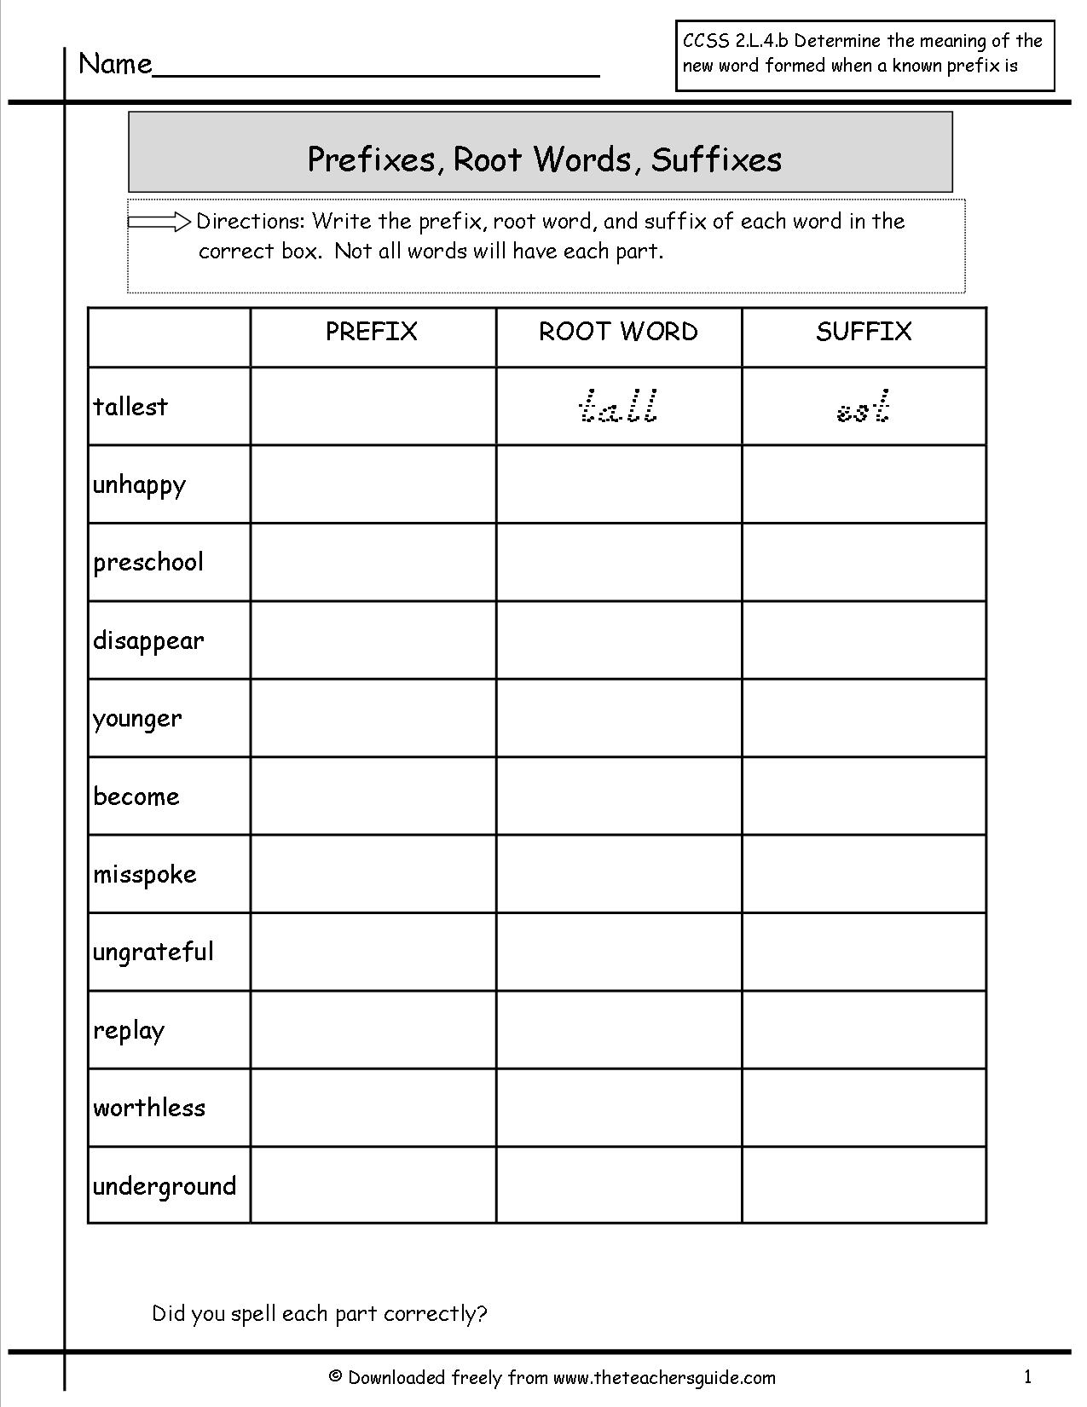

**Estude as condicionais antes dos exercicios:

1. First conditional: | If I have enough money, I will go to Japan.
2. Second conditional: | If I had enough money, I would go to Japan.
3. Third conditional: | If I had had enough money, I would have gone to Japan.

8) Put the sentences in the conditional form:

- If we meet at 9:30, we ____________________(to have) plenty of time.
- Lisa would find the milk if she ________________ (to look) in the fridge.
- The zookeeper would have punished her with a fine if she ___________________ (to feed) the animals.
- If you spoke louder, your classmates _______________________ (to understand) you.
- Dan ___________________________ (to arrive) safe if he drove slowly.
- You ____________________________ (to have) no trouble at school if you had done your homework.
- If you ____________________ (to swim) in this lake, you'll shiver from cold.
- The door will unlock if you __________________________ (to press) the green button.
- If Mel ____________________________ (to ask) her teacher, he'd have answered her questions.
- I _____________________________ (to call) the office if I was/were you.

9) Write the sentences in the passive voice:
a) I will take the children to the cinema._______________________________________________
b) The girls have prepared this delicious cake.___________________________________________
c) The students wrote these interesting texts about the school trip._______________________________________________
d) The customers have just read the notice. _____________________________________________
e) Many people study English at language schools.________________________________________
f) The Smiths bought the green house._________________________________________________
10) Passive or active voice?

- The grapes are grown in California. ____________________
- The hamster can be kept in a cage._____________________
- The party has already started. _______________________
- The car is standing at the garage. ______________________
- The ship has been given up. ___________________________
- The police didn't find the robber last week. ____________________
- The first fast food restaurants were opened in the USA in 1916. _____________________
- The train is going to arrive late. _____________________

11) Find the adjective in the first sentence and fill in the blanks with the corresponding adverb:

- James is careful. He drives ______________________
- The girl is slow. She walks ______________________
- Her English is perfect. She speaks English __________________
- Our teacher is angry. She shouts ______________________
- My neighbor is a loud speaker. He speaks ____________________
- He is a bad writer . He writes _____________________________
- Jane is a nice guitar player. He plays the guitar ______________________
- He is a good painter . He paints ________________________
- She is a quiet girl. She does her job ___________________________
- This exercise is easy. You can do it ____________________________
12) Choose the correct form of the indefinite pronouns :
SOMEWHERE, ANYWHERE, NOWHERE, EVERYWHERE, SOMETHING, ANYTHING, NOTHING, EVERYTHING, SOMEBODY, ANYBODY, NOBODY, EVERYBODY!
a.I am sure I put down my keys ___________________
b.Calm down. There is _______________to worry about.
c.Let's sit down ________________and talk.
d.I heard a knock at the door but there was _________________there.
e.We didn't see _____________________
f.The restaurant was really crowded. _________________ had a good time.
g.Be quite ! __________________ is coming.
h.I don't think _________________knows the answer to that question.
i.She can't go ___________________without people recognizing her.
j.I have _________________to tell you.

GOOD LUCK!


